Optimization Model (Equation)

Decision Variables:
• Xi,j = quantity of cobalt transported from supplier i to consumer j

Parameters:
• Ci,j= transportation cost per unit of cobalt from i to j
• Ei,j = emissions per unit of cobalt transported from i to j
• Qj = demand for cobalt at consumer j
• Si = supply capacity of cobalt at supplier i
• λ = weight parameter to balance cost and emissions (0 for cost-only, 1 for emissions-only, and 0.5 for equal importance)

Minimize Cost
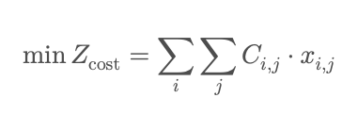

Minimize Emissions
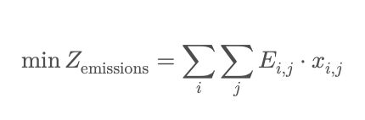

Minimize combined Cost and Emissions
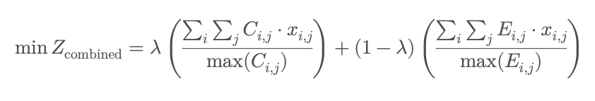
Supply Capacity Constraint
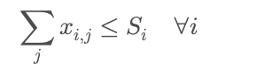

Demand Satisfaction Constraint
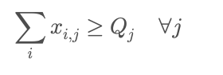

Non-negativity Constraint
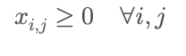

If we try to consider also FTAs, tariffs and non-tariffs
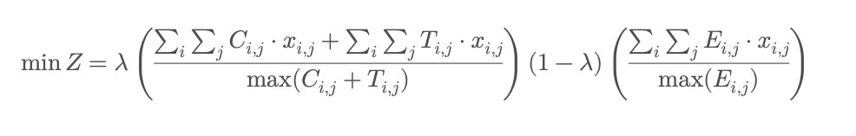
With
• Ti,j = tariff or non-tariff cost associated with transporting cobalt from i to j (can include penalties for geopolitical risks or regions outside FTAs)

Additional FTA Constraint (Fi,j is a binary variable that equals 1 if trade between i and j is allowed under an FTA, otherwise 0)

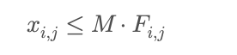

Additional Geopolitical Risk Constraint (Ri,j represents a risk-adjusted limit on trade between locations i and j)

